PRESTO (TRINO) – COMPLETE GUIDE
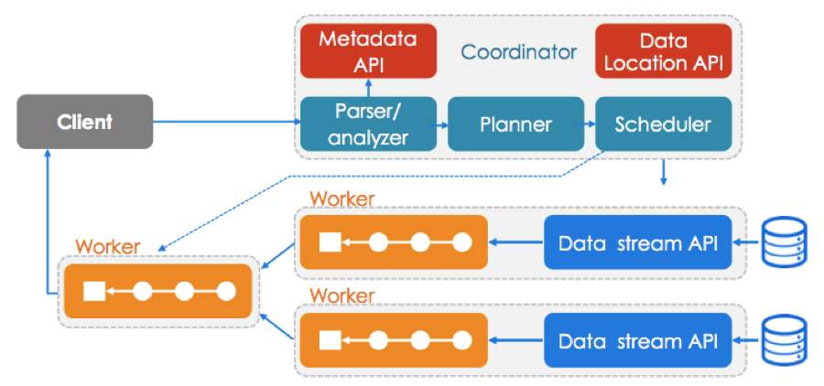
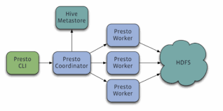
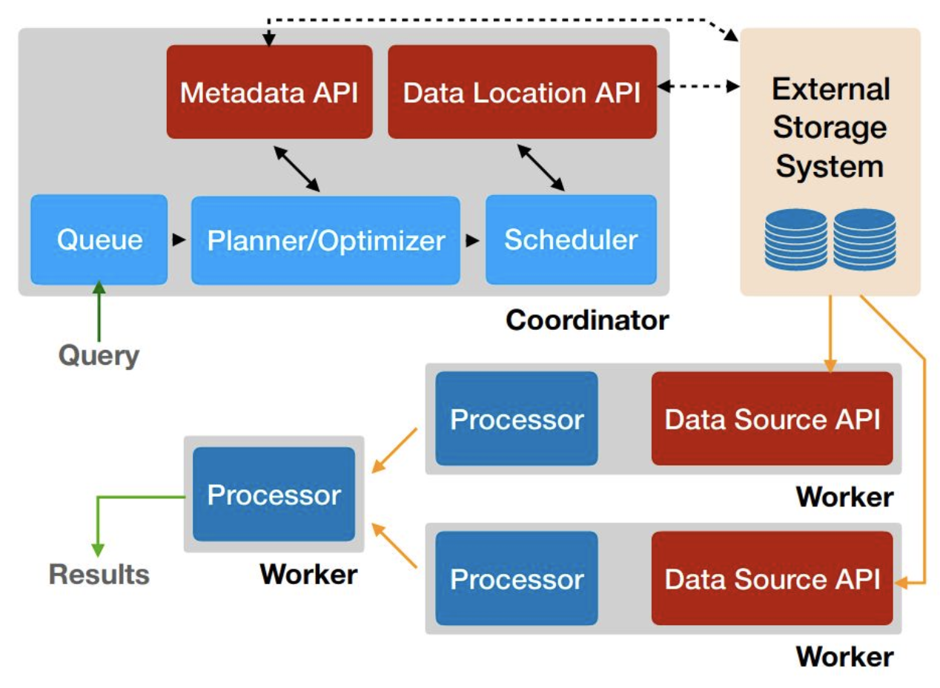

1. What is Presto (Trino)?
Presto is a distributed, in-memory SQL query engine designed for fast, interactive analytics on large datasets.
Presto does not store data.
It queries data where it already lives, such as:
Hive / HDFS / S3, MySQL, PostgreSQL, Kafka, Iceberg, Delta Lake.
Presto focuses on low-latency SQL queries (seconds), not transactions.

2. Why Presto Exists (Problem It Solves)
Traditional databases like MySQL are excellent for transactions but slow when:
data becomes very large,
queries scan millions of rows,
analytics span multiple systems.
Presto solves this by:
executing queries in parallel across many workers,
processing data in memory,
allowing federated queries across multiple data sources.

3. Presto vs MySQL (Very Important)
Execution Model
MySQL executes queries row-by-row, mostly on a single server.
Presto distributes query execution across many worker nodes.
Data Storage
MySQL stores data inside its own database engine.
Presto does not store data at all.
Performance Focus
MySQL is optimized for OLTP (INSERT, UPDATE, DELETE).
Presto is optimized for OLAP (SELECT, GROUP BY, JOIN).
Typical Use Case
MySQL is used for applications.
Presto is used for analytics, BI dashboards, and ad-hoc analysis.
One-Line Interview Answer
MySQL is for transactions, Presto is for fast analytics on large data.

4. Presto Architecture (Simple View)
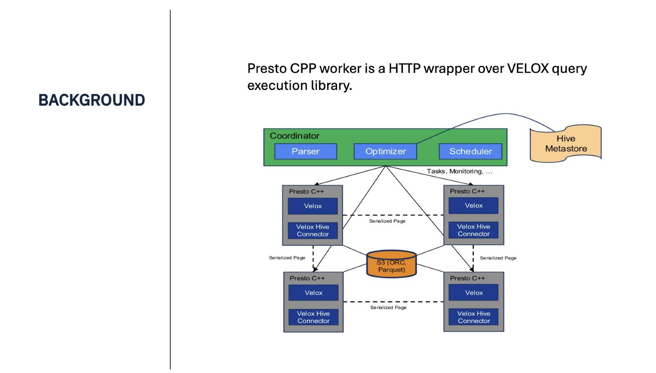
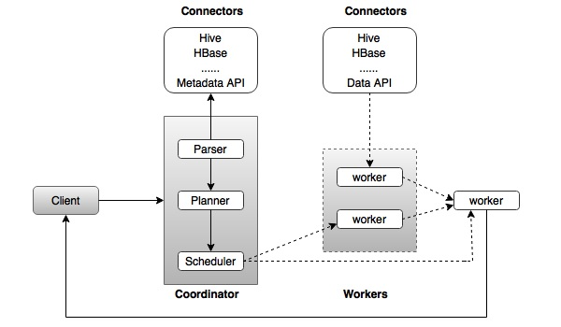
Presto has two main components.
Coordinator
Accepts SQL queries, builds execution plans, schedules work.
Workers
Execute query fragments in parallel and stream results back.
Data is read directly from source systems using connectors.

5. Presto Setup Using Docker (Learning Setup)
This setup is perfect for learning and practice.

Step 1: Prerequisites
Docker installed
Docker Compose installed

PART 1: Install & Prepare MySQL (LOCAL MACHINE)
Step 1: Install MySQL
If MySQL is not installed, install MySQL Server 8.x.
Verify installation:

Step 2: Start MySQL and Login
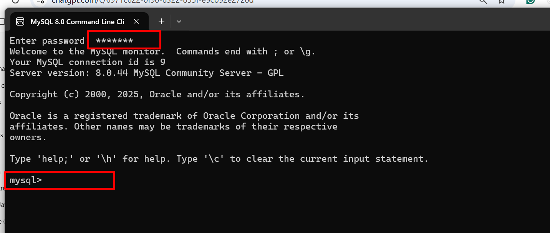

Step 3: Create Database and Table (Sample Data)
CREATE DATABASE sales;
USE sales;

CREATE TABLE customers (
id INT PRIMARY KEY,
name VARCHAR(50),
city VARCHAR(50)
);

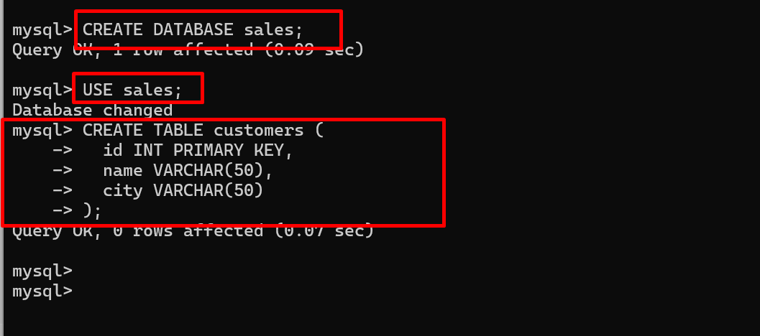

INSERT INTO customers VALUES
(101,'Akash','Pune'),
(102,'Rahul','Mumbai'),
(103,'Sneha','Bangalore'),
(104,'Neha','Delhi');

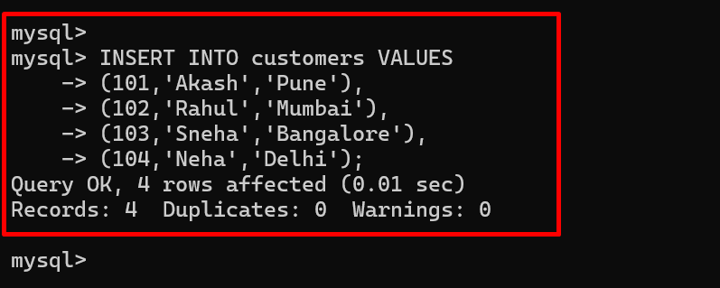

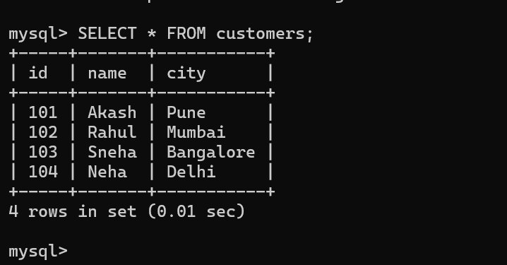

Step 4: Allow MySQL Access from Docker (IMPORTANT)

GRANT ALL PRIVILEGES ON sales.* TO 'root'@'%';
FLUSH PRIVILEGES;

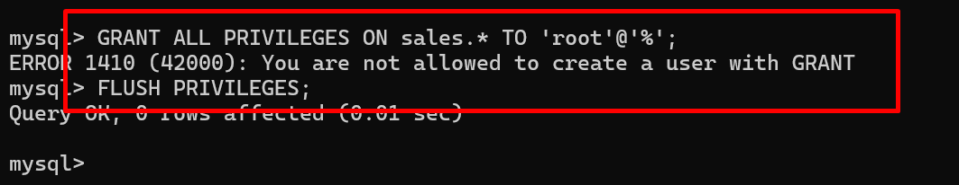

This allows Presto (Docker) to connect to MySQL.

PART 2: Prepare Presto (Trino) on Docker
Presto

Step 5: Create Presto Catalog Folder (ON HOST)
Create this folder:
Windows

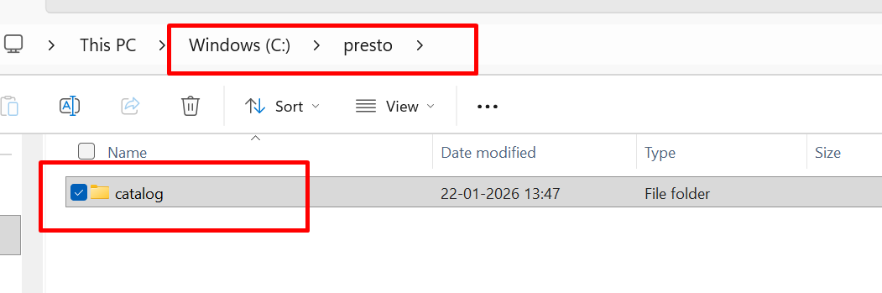

Step 6: Create MySQL Connector File
Create file:

mysql.properties

Location:
C:\presto\catalog\mysql.properties

connector.name=mysql
connection-url=jdbc:mysql://host.docker.internal:3306
connection-user=root
connection-password=YOUR_MYSQL_PASSWORD

Important:
Use host.docker.internal, not localhost.

PART 3: Run Presto in Docker
Step 7: Start Presto Container
Windows

docker run -d ^
--name presto ^
-p 8080:8080 ^
-v C:/presto/catalog:/etc/trino/catalog ^
trinodb/trino:latest

Linux/Unix

docker run -d \
--name presto \
-p 8080:8080 \
-v ~/presto/catalog:/etc/trino/catalog \
trinodb/trino:latest

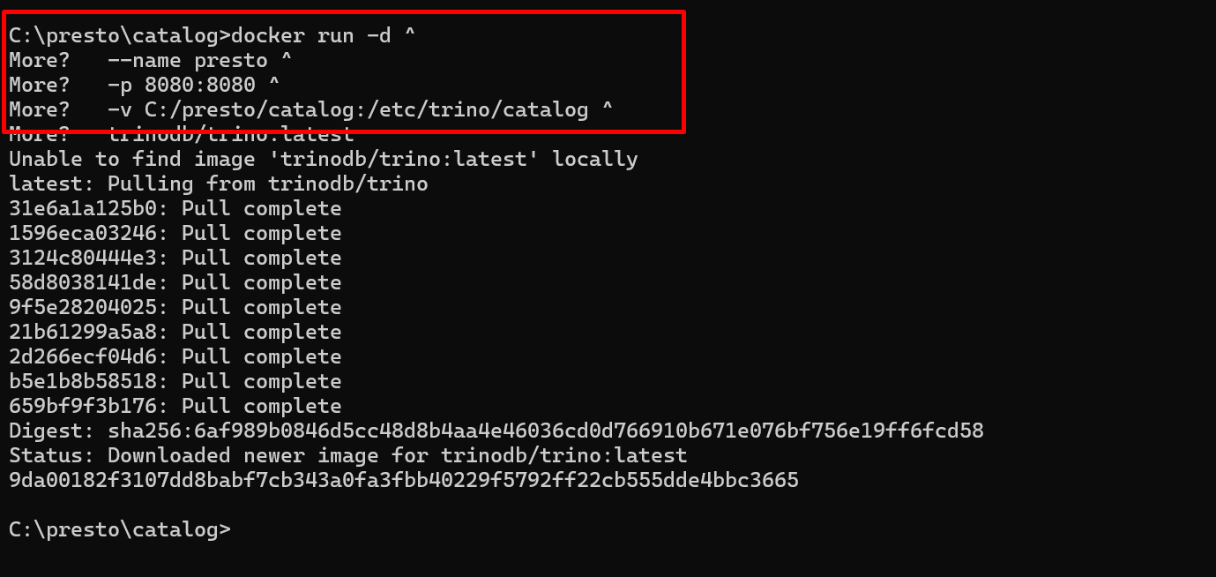

Check the docker imges
Using below command
docker images

Using docker ps verify service up or not
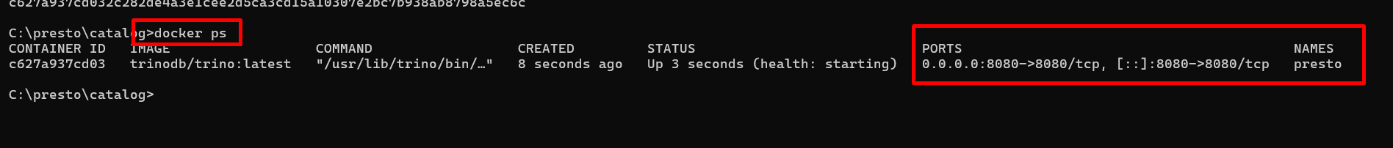

Make sure service running properly. If you need open docker desktop and check the status

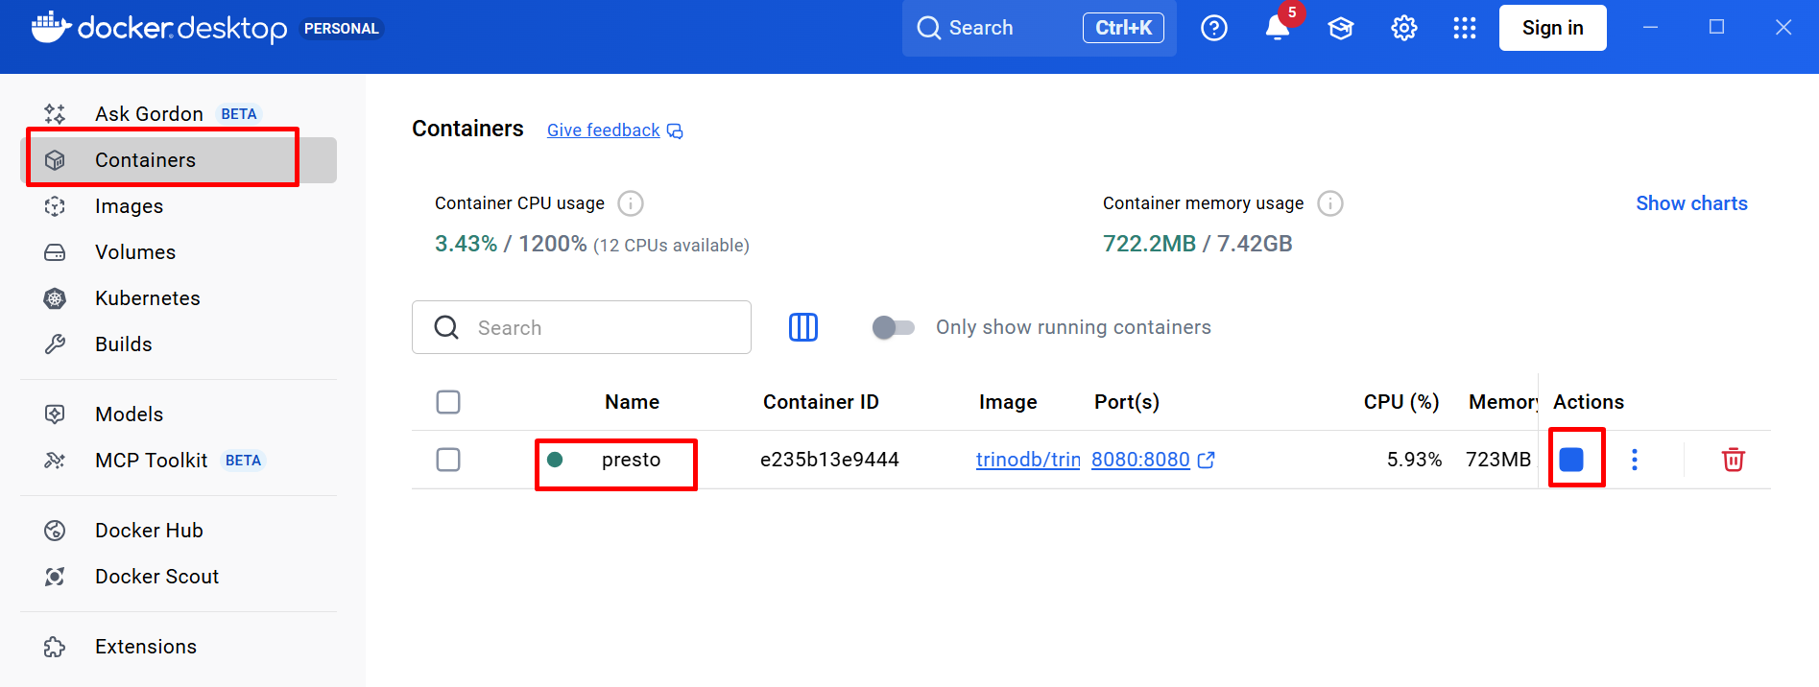

Step 8: Open Presto CLI
Once container is running:

docker exec -it presto trino
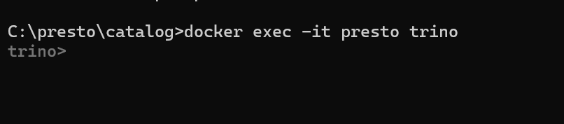

In Trino terminology:
catalog → schema → table
Mapping for MySQL:
catalog = mysql(or any other database)
schema = database (sales)
table = customers

Next Correct Command (Step by Step)
Step 1: Show Schemas (Databases) in MySQL

show catalogs

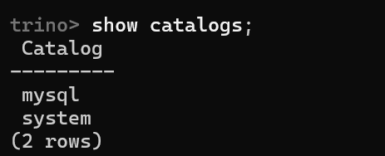

Next Correct Command (Step by Step)
Step 1: Show Schemas (Databases) in MySQL
SHOW SCHEMAS FROM mysql;

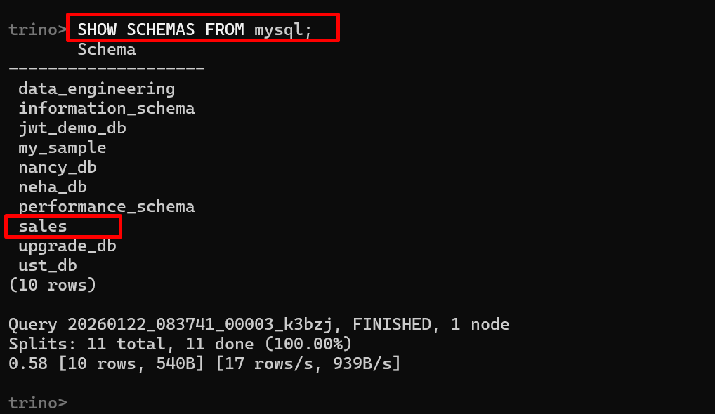

Step 2: Show Tables in sales Schema
SHOW TABLES FROM mysql.sales;

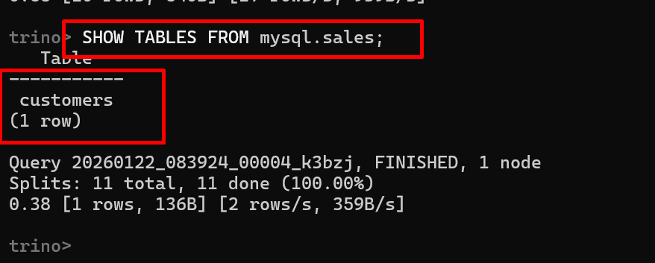

Expected output:
customers

Step 3: Query the Table (Final Proof)
SELECT * FROM mysql.sales.customers;

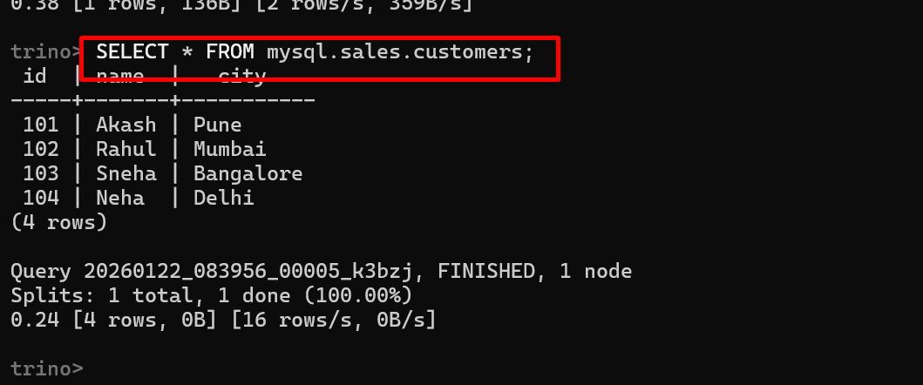

NTERMEDIATE TRINO QUERIES (ANALYTICS & BI)

1. Filter Customers by City
Use case
Dashboard filtering, location-based analytics.
SELECT *
FROM mysql.sales.customers
WHERE city = 'Pune';
What Trino does
Pushes filter to MySQL → fetches only matching rows.

2. Count Customers per City
Use case
Customer distribution report.

SELECT city, COUNT(*) AS total_customers
FROM mysql.sales.customers
GROUP BY city;

Internal
Partial aggregation → final aggregation in Trino.

3. Sort Customers Alphabetically
Use case
UI dropdowns, reports.

SELECT *
FROM mysql.sales.customers
ORDER BY name;

4. Case Expression (Business Logic)
Use case
Customer segmentation.
SELECT name, city,
CASE
WHEN city IN ('Pune','Mumbai') THEN 'WEST'
ELSE 'OTHER'
END AS region
FROM mysql.sales.customers;

5. Pattern Search
Use case
Search feature in applications.
SELECT *
FROM mysql.sales.customers
WHERE name LIKE 'A%';

6. DISTINCT Cities
Use case
Filters, dropdowns, analytics.
SELECT DISTINCT city
FROM mysql.sales.customers;

7. Limit Result Set
Use case
Preview data, reduce memory usage.
SELECT *
FROM mysql.sales.customers
LIMIT 3;
Trino optimization
LIMIT pushed early → minimal data transfer.

8. Execution Plan (IMPORTANT)
Use case
Performance tuning, interviews.
EXPLAIN
SELECT city, COUNT(*)
FROM mysql.sales.customers
GROUP BY city;

ADVANCED TRINO QUERIES (REAL INTERVIEW + PROJECT LEVEL)

9. Window Function – Row Number
Use case
Pagination, ranking.
SELECT name, city,
ROW_NUMBER() OVER (ORDER BY name) AS rn
FROM mysql.sales.customers;

10. Window Function – Rank
Use case
Leaderboard-style ranking.
SELECT name, city,
RANK() OVER (ORDER BY name) AS rnk
FROM mysql.sales.customers;

11. City-wise Ranking
Use case
Top customers per region (real analytics).
SELECT name, city,
ROW_NUMBER() OVER (PARTITION BY city ORDER BY name) AS city_rank
FROM mysql.sales.customers;

12. EXPLAIN ANALYZE (MOST IMPORTANT)
Use case
Production debugging, performance interviews.
EXPLAIN ANALYZE
SELECT city, COUNT(*)
FROM mysql.sales.customers
GROUP BY city;

Shows:
Actual execution time
Rows processed
Memory used

13. Subquery Usage
Use case
Complex analytics logic.
SELECT *
FROM (
SELECT name, city
FROM mysql.sales.customers
WHERE city <> 'Delhi'
) t
WHERE name LIKE 'R%';

14. Conditional Aggregation
Use case
Business KPIs.
SELECT
COUNT(*) AS total,
COUNT(CASE WHEN city='Pune' THEN 1 END) AS pune_customers
FROM mysql.sales.customers;

15. UNION ALL
Use case
Merge multiple sources.
SELECT name FROM mysql.sales.customers WHERE city='Pune'
UNION ALL
SELECT name FROM mysql.sales.customers WHERE city='Mumbai';

16. COALESCE (Null Handling)
Use case
Data cleansing.
SELECT name, COALESCE(city,'UNKNOWN') AS city
FROM mysql.sales.customers;

17. String Functions
Use case
Data formatting.
SELECT
UPPER(name) AS upper_name,
LENGTH(name) AS name_length
FROM mysql.sales.customers;

18. Date Simulation (Analytics Style)
Use case
Time-based reporting (even if MySQL table has no date).
SELECT name,
CURRENT_DATE AS report_date
FROM mysql.sales.customers;

19. System Metadata Queries (Trino Only)
Use case
Monitoring, debugging.
SELECT * FROM system.runtime.nodes;
SELECT * FROM system.runtime.queries;

20. Performance-Friendly Query Pattern
Use case
Avoid OOM in Trino.
SELECT *
FROM mysql.sales.customers
ORDER BY name
LIMIT 5;
Why important
Sorting full dataset without LIMIT can cause memory issues.

VERY IMPORTANT INTERVIEW USE CASES

Use Case 1: Why use Trino over MySQL for analytics?
Because Trino executes queries in parallel and supports cross-source analytics.

Use Case 2: When NOT to use Trino?
For INSERT/UPDATE/DELETE heavy workloads.

Use Case 3: What makes Trino fast?
In-memory pipeline execution + parallelism.

FINAL REAL-WORLD QUERY FORMAT TO REMEMBER
catalog.schema.table
Example:
mysql.sales.customers

MySQL vs Trino — SAME QUERY COMPARISON
MySQL
Presto (Trino)

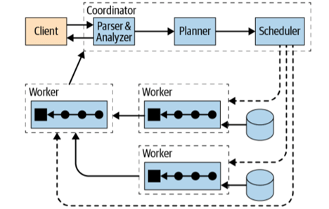

DATA USED (Same for Both)
Table:
customers(id, name, city)
Records:
101 Akash Pune
102 Rahul Mumbai
103 Sneha Bangalore
104 Neha Delhi

1️⃣ SIMPLE SELECT (FULL TABLE SCAN)
Query (Same SQL)
SELECT * FROM customers;
MySQL
Where it runs
Inside MySQL server
How it executes
Single process
Row-by-row scan
Reads from buffer pool / disk
Best for
Small tables
Transactional apps

Trino
Query used:
SELECT * FROM mysql.sales.customers;
Where it runs
Inside Trino container
How it executes
Uses JDBC connector
Streams rows from MySQL
Processes in memory
Best for
Analytics
Federated queries

Verdict
For small tables → MySQL faster
For analytics pipelines → Trino acceptable

2️⃣ FILTER QUERY (WHERE CLAUSE)
Query
SELECT * FROM customers WHERE city = 'Pune';
MySQL
Execution
Index lookup (if index exists)
Otherwise table scan
Execution plan:
EXPLAIN SELECT * FROM customers WHERE city='Pune';

Trino
Query:
SELECT * FROM mysql.sales.customers WHERE city='Pune';
Execution
Predicate pushdown to MySQL
Only filtered rows are fetched

Verdict
With index → MySQL wins
Without index → Equal

3️⃣ GROUP BY (ANALYTICS QUERY)
Query
SELECT city, COUNT(*) FROM customers GROUP BY city;
MySQL
Execution
Single-node aggregation
CPU bound
Slower as data grows

Trino
Query:
SELECT city, COUNT(*) FROM mysql.sales.customers GROUP BY city;
Execution
Parallel partial aggregation
Final aggregation in memory

Verdict
Small data → Similar
Large data → Trino much faster

4️⃣ ORDER BY (SORTING)
Query
SELECT * FROM customers ORDER BY name;
MySQL
Execution
Uses index (if exists)
Otherwise filesort

Trino
Query:
SELECT * FROM mysql.sales.customers ORDER BY name;
Execution
In-memory sort
High memory usage

Verdict
Indexed sort → MySQL wins
Large analytics → Trino with LIMIT

5️⃣ LIMIT (OPTIMIZATION DIFFERENCE)
Query
SELECT * FROM customers ORDER BY name LIMIT 2;
MySQL
Execution
Sort + limit
Index helps

Trino
Execution
LIMIT pushed early
Less data transferred
Lower memory usage

Verdict
Both efficient
Trino safer for analytics

6️⃣ WINDOW FUNCTION (IMPORTANT)
Query
SELECT name, city,
ROW_NUMBER() OVER (ORDER BY name) rn
FROM customers;
MySQL
Execution
Supported only in newer versions
Single-node execution

Trino
Query:
SELECT name, city,
ROW_NUMBER() OVER (ORDER BY name) rn
FROM mysql.sales.customers;
Execution
Distributed window processing
Parallel pipelines

Verdict
Complex analytics → Trino wins

7️⃣ JOIN (REAL INTERVIEW FAVORITE)
Assume another table: orders
Query
SELECT c.name, o.amount
FROM customers c
JOIN orders o
ON c.id = o.customer_id;
MySQL
Execution
Nested loop / hash join
Single node
Index dependent

Trino
Query:
SELECT c.name, o.amount
FROM mysql.sales.customers c
JOIN mysql.sales.orders o
ON c.id = o.customer_id;
Execution
Distributed hash join
Parallel execution
In-memory

Verdict
Small data → MySQL
Large joins → Trino

8️⃣ EXPLAIN vs EXPLAIN ANALYZE
MySQL
EXPLAIN SELECT city, COUNT(*) FROM customers GROUP BY city;
Shows
Index usage
Estimated rows

Trino
EXPLAIN ANALYZE
SELECT city, COUNT(*) FROM mysql.sales.customers GROUP BY city;
Shows
Actual execution time
Rows processed
Memory usage

Verdict
Debugging analytics → Trino

9️⃣ CROSS-DATABASE QUERY (IMPOSSIBLE IN MYSQL)
Query
SELECT c.name, o.amount
FROM mysql.sales.customers c
JOIN hive.sales_db.orders o
ON c.id = o.customer_id;
MySQL
❌ Impossible
Trino
✅ Native feature

FINAL COMPARISON TABLE (INTERVIEW GOLD)
Feature | MySQL | Trino
OLTP | ✅ | ❌
Analytics | ⚠️ | ✅
Joins | Single-node | Distributed
Window Functions | Limited | Powerful
Cross DB Queries | ❌ | ✅
Memory Based | ❌ | ✅
INSERT/UPDATE | ✅ | ❌

ONE-LINE INTERVIEW ANSWERS
Q: Why Trino over MySQL?
For fast analytics and federated queries on large datasets.
Q: Why MySQL over Trino?
For transactional workloads and frequent updates.

